# Homework: Problem Solving Methodology

This document defines the **homework assignments** for the ["Algortihms" course @ Software University](https://softuni.bg/opencourses/algorithms).

## Shortest Path in Matrix

Write a program to find the **shortest path in a matrix of numbers** from the top-left corner to the bottom-right corner. The path consists of a sequence of cells, each sharing a common side with its next cell.

You will receive the number of **rows N** on the first line and the number of **columns M** on the second line. On each of the next N lines you’ll receive the cells’ values as a sequence of M **positive integers separated by a single space**.

Print the length of the path (sum of cell values) on the first line in format "Length: {length}". On the second line, print the path in format "Path: {cell1} {cell2} …". You can test your solution in the Judge system [here](https://judge.softuni.bg/Contests/Practice/Index/114#7).

**Note**: If multiple paths exist, print the one which moves through cells with lowest row and then column (traverse the matrix from top to bottom and from left to right).

Examples:

|  |  |  |
| --- | --- | --- |
| **Input** | **Output** | **Path (Visualized)** |
| 5  4  2 4 5 6  9 1 1 5  8 7 1 9  8 2 4 9  8 2 2 7 | Length: 22  Path: 2 4 1 1 1 4 2 7 |  |
| 5  4  1 1 1 1  8 6 4 1  1 1 1 1  1 4 6 8  1 1 1 1 | Length: 14  Path: 1 1 1 1 1 1 1 1 1 1 1 1 1 1 |  |
| 5  4  1 1 1 1  8 4 4 1  1 1 1 1  1 4 6 8  1 1 1 1 | Length: 13  Path: 1 1 4 1 1 1 1 1 1 1 |  |

**Hint**: Build a graph and use **Dijkstra’s algorithm**.

## Rectangle Intersection

You are given N **rectangles** in the plane. The rectangles are parallel to the coordinate axes and each is defined by its coordinates: {minX, maxX, minY, maxY}. Write a program to find the **total area** of all areas that belong to more than one of the initial rectangles. All coordinates are integers in the **range [-1000, 1000]**. Example:

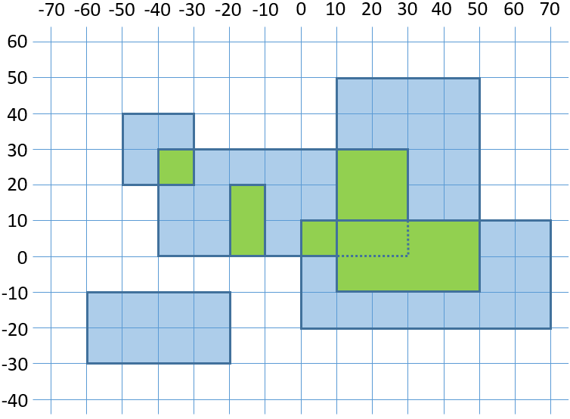

We have 6 rectangles. Their intersection areas are shown in green. The intersection area is 1600.

On the first line you’ll receive the **number of rectangles N**. On the next N lines, you’ll receive the coordinates of each rectangle in format {minX} {maxX} {minY} {maxY}. On the only output line, print the total area belonging to more than one rectangle. You can test your solution in the Judge system [here](https://judge.softuni.bg/Contests/Practice/Index/114#8).

Examples:

|  |  |
| --- | --- |
| **Input** | **Output** |
| 6  -60 -20 -30 -10  -50 -30 20 40  -40 30 0 30  10 50 -10 50  0 70 -20 10  -20 -10 0 20 | 1600 |
| 3  40 80 -40 0  20 60 -20 30  50 100 -10 20 | 800 |
| 9  -851 88 546 659  990 999 608 998  815 835 -517 734  157 623 994 996  947 956 529 925  561 688 -241 434  -966 530 -825 273  396 780 -705 590  110 202 713 891 | 216777 |

### Hints

* **Solution #1 (slow)**
  + Create a **matrix of size 2001 x 2001**.
  + **Paint** all rectangles in the matrix.
  + **Count** the painted cells.
* **\* Solution #2 (faster)**
  + Extract all **X coordinates** x[] from all rectangles (minX and maxX) and **sort them** in increasingly.
  + For each two coordinates x[i] and x[i+1] find all rectangles rects[] that overlap with this interval, sorted by minY. To implement this efficiently, first pre-calculate the list of rectangles for each interval x[i] … x[i+1] by a single scan through the initial list of rectangles.
  + Extract all **Y coordinates** y[] from all rectangles rect[] (minY and maxY) and **sort them** in increasing order.
  + For each two coordinates y[i] and y[i+1] find how many rectangles overlap with this interval, **calculate the area** where rect_count ≥ 2 and **sum** **it**. To implement this efficiently, first pre-calculate the number of overlapping rectangles for each interval y[i] … y[i+1] by a single scan through rect[].
* *** **Solution #3 (fastest)**
  + Implement a solution based on **interval trees** as described in <http://www.oi.edu.pl/static/attachment/20110713/boi-2001.pdf> (see problem “**Mars Maps**”)